

FDA approved Sotyktu for active PsA

Company: BMS  Drug: Sotyktu (deucravacitinib, oral TYK2 inhibitor) | Date: March 6th, 2026  Source(s): Press release, FDA label

What happened:
- On its March 6th PDUFA date, the FDA approved Sotyktu (deucravacitinib, oral TYK2 inhibitor) for the treatment of adults with active psoriatic arthritis (PsA)
  - Approval is based on the positive results from the Phase 3 POETYK PsA-1 and POETYK PsA-2 studies
  - Approved dosage: 6mg once daily in adults
  - Consistent with the PsO label, Sotyktu is associated with the following warnings and precautions: hypersensitivity reactions, infections, tuberculosis, malignancy including lymphomas, rhabdomyolysis and elevated CPK, laboratory abnormalities, immunizations, and potential risks related to JAK inhibition
- The FDA label and HCP website have been updated; the patient website has not been updated yet to reflect the approval

Impact (CI PoV): HIGH
- The FDA approval makes Sotyktu the first and only oral TYK2 inhibitor approved for adults with active PsA, expanding its 2022 approval in moderate-to-severe plaque psoriasis (PsO)
  - This approval allows BMS to establish early physician familiarity and real-world evidence ahead of emerging oral competitors such as JNJ’s Icotyde (icotrokinra, oral IL-23R antagonist) and Takeda’s Zasocitinib (TAK-279, oral TYK2 inhibitor), with approvals expected in Q1 2028 and Q3 2028, respectively

Why it matters (CI Insights in blue italics):
- The approval offers a new once-daily oral option that may appeal to patients seeking an alternative to injectable biologics while potentially providing a more manageable safety and monitoring profile than JAK inhibitors
  - Sotyktu’s uptake in PsA will likely depend in part on the level of commercial support BMS allocates to the indication, particularly following its removal from promotional activities in dermatology in the US and several ex-US markets


Tell me more:
- FDA approval is supported by the Phase 3 multicenter, randomized, double-blind, placebo-controlled POETYK-PsA-1 and POETYK-PsA-2 trials that evaluated the safety and efficacy of Sotyktu in adults with active PsA
- Study Design
  - POETYK PsA-1 included 670 patients with active PsA who were bDMARD naïve
  - POETYK PsA-2 included 624 patients with active PsA who were bDMARD naïve or had previously received TNFα inhibitor treatment; the trial also included an apremilast safety reference arm
  - Primary endpoint: ACR20 at Week 16
- Study Results
  - Efficacy:
    - Both trials met their primary endpoints, demonstrating sustained improvements across joint pain and swelling as well as psoriatic skin lesions
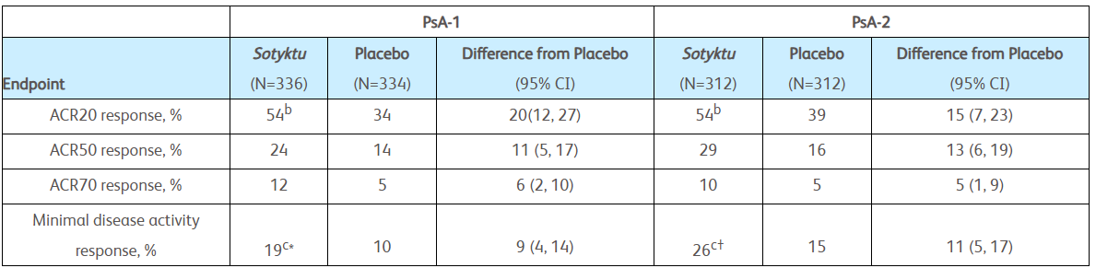

  - Safety:
    - The overall safety profile in active PsA was generally consistent with the safety profile previously seen in PsO
    - Most common adverse reactions were upper respiratory infections, increased blood creatine phosphokinase, herpes simplex, mouth ulcers, folliculitis, and acne
  - HRQoL:
    - Improvements were seen in SF-36 PCS score at Week 16 compared to placebo (key secondary endpoint)
    - Improvements were also reported across all four SF-36 PCS domain scale scores: physical functioning, role-physical, bodily pain, and general health
- Outlook:
  - Regulatory applications for Sotyktu are under review in the EU, Japan and China
    - CI anticipates earliest EU approval in Q2 2026, assuming a positive CHMP opinion in the coming months and a standard ~67-day EC decision; despite inclusion in CHMP agenda in January, no mention of Sotyktu occurred in the January or February 2026 meeting materials
    - CI anticipates Japan and China approval in Q3 and Q4 2026, respectively
  - Pediatric PsA: Phase 3 study ongoing; PCD: March 2030; CI anticipates earliest US/EU approval in Q2 2031 (supplemental review)
  - SLE: Phase 3 POETYK-SLE-1 & POETYK-SLE-2 ongoing, with data expected in 2026; PCDs: October 2026; CI anticipates earliest US approval in Q4 2027
  - SjD: Phase 3 POETYK-SjS-1 ongoing, with data expected in 2027; PCD: November 2026

For questions, please reach out to:
 | Dermatology | Rheumatology | Gastroenterology
APEX (US/PCS) | Chanda Bhat | Bethany Christmann | Luke Versten
IMABI (International/ Affiliates) | Priti Anand | Irene Knorn | Priti Anand

Invite your colleagues to inVision | Manage Email Preferences | Unsubscribe

This document contains competitive intelligence collected via AbbVie approved methods or vendors. We collect competitive intelligence consistent with industry standards and AbbVie policy. Not for commercial field use. Please reach out to CI, Legal or OEC with any questions.

